Convex Shapes
# Source: AI Source: Provided by: [Data Path: Persons Table -> ID Column: 1, Name_En Column: Motasem Essam] -> From: [ChatGPT] on [7/25/2026]
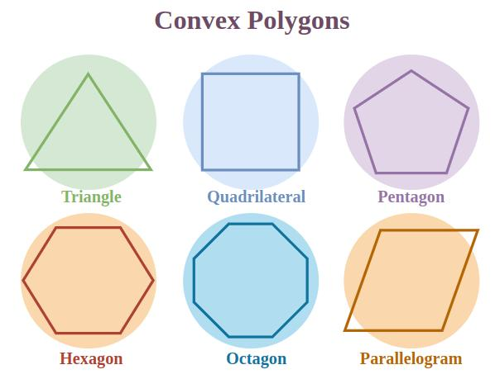
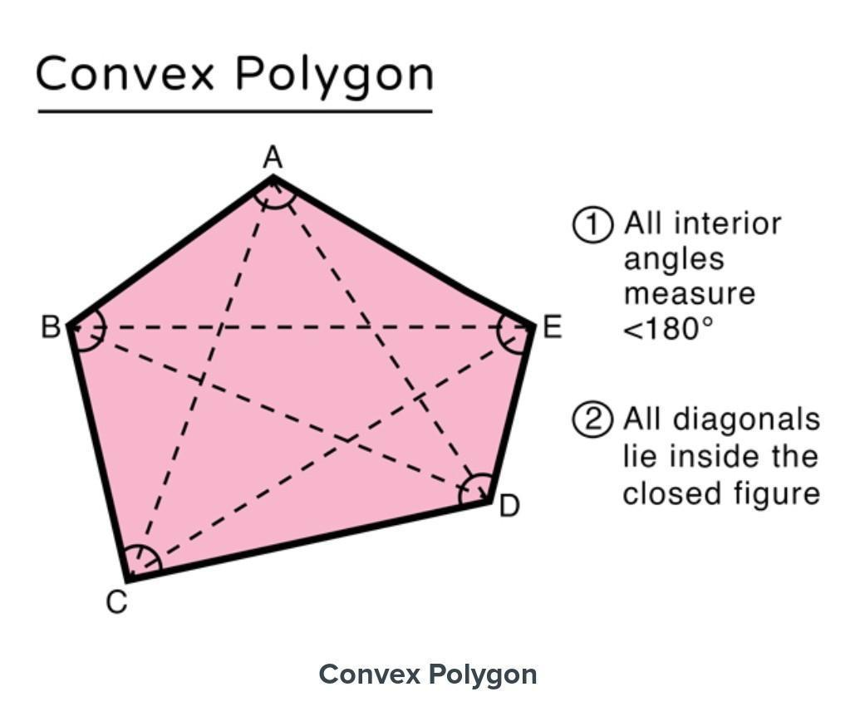
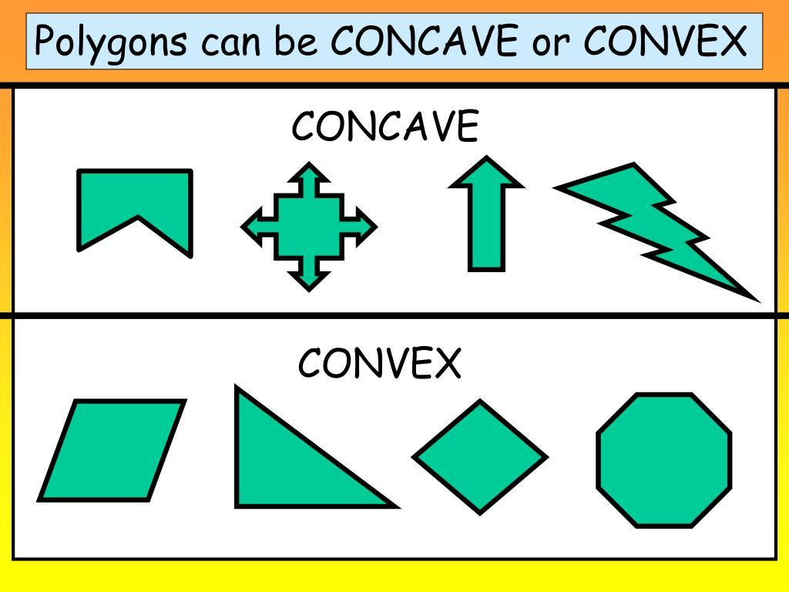
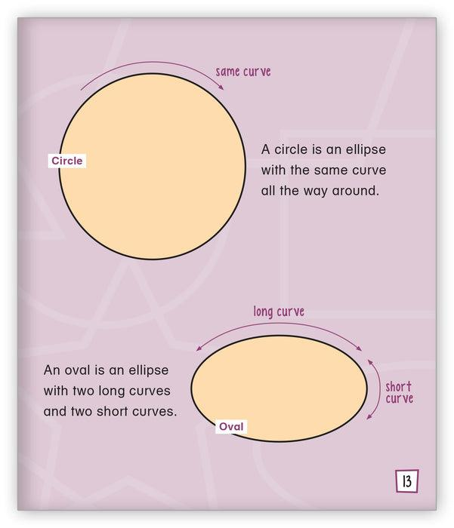
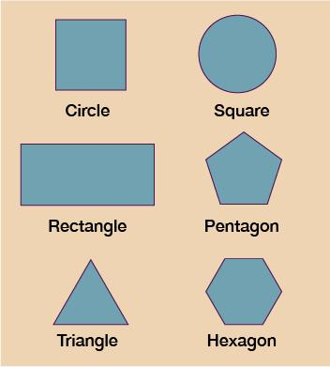
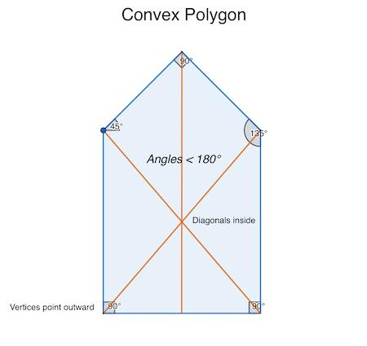

Definition
# Source: AI Source: Provided by: [Data Path: Persons Table -> ID Column: 1, Name_En Column: Motasem Essam] -> From: [ChatGPT] on [7/25/2026]
A Convex Shape is a two-dimensional geometric figure in which every line segment connecting any two points inside the shape lies completely inside the shape.
In simple terms:
A shape is convex if it has no inward dents or indentations.
All interior angles of a convex polygon are less than ${180}^{∘}$.

Characteristics
# Source: AI Source: Provided by: [Data Path: Persons Table -> ID Column: 1, Name_En Column: Motasem Essam] -> From: [ChatGPT] on [7/25/2026]
A convex shape:
- Has no inward curves or dents.
- Contains all connecting line segments between internal points.
- Has a boundary that always bends outward.
- May be polygonal, curved, or mixed.
- Usually has a clear interior region.
- Has all interior angles less than:
$${180}^{∘}$$
(for polygons).

Illustration

Convex Polygon (Triangle)
# Source: AI Source: Provided by: [Data Path: Persons Table -> ID Column: 1, Name_En Column: Motasem Essam] -> From: [ChatGPT] on [7/25/2026]
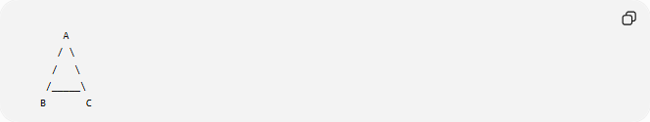
A
/ \
/ \
/_____\
B C
Any line between two points inside the triangle remains inside.

Convex Polygon (Square)
# Source: AI Source: Provided by: [Data Path: Persons Table -> ID Column: 1, Name_En Column: Motasem Essam] -> From: [ChatGPT] on [7/25/2026]
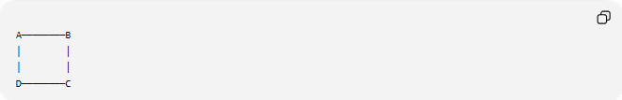
A────────B
│ │
│ │
D────────C
All angles are:
$${90}^{∘}<{180}^{∘}$$

Convex vs Concave
# Source: AI Source: Provided by: [Data Path: Persons Table -> ID Column: 1, Name_En Column: Motasem Essam] -> From: [ChatGPT] on [7/25/2026]
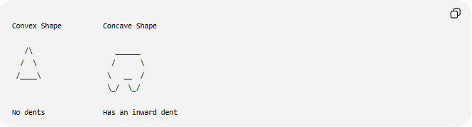
Convex Shape Concave Shape

/\ ______
/ \ / \
/____\ \ __ /
\_/ \_/

No dents Has an inward dent

Mathematical Definition
# Source: AI Source: Provided by: [Data Path: Persons Table -> ID Column: 1, Name_En Column: Motasem Essam] -> From: [ChatGPT] on [7/25/2026]
A set (S) is convex if:
For any two points:
$$A,B∈S$$
the entire line segment:
$$\overline{AB}$$
is also contained in $S$.
Mathematically:
$$∀A,B∈S, tA+\left(1-t\right)B∈S$$
where:
$$0≤t≤1$$

Convex Polygon Properties
# Source: AI Source: Provided by: [Data Path: Persons Table -> ID Column: 1, Name_En Column: Motasem Essam] -> From: [ChatGPT] on [7/25/2026]
For a convex polygon:
Interior Angles
Every interior angle satisfies:
$$0^{∘}<θ<{180}^{∘}$$

Diagonals
All diagonals lie completely inside the polygon.
Example:
A convex pentagon:
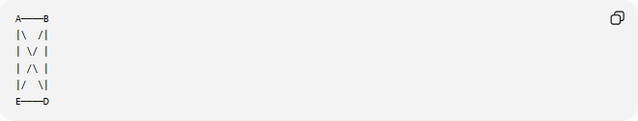
A────B
|\ /|
| \/ |
| /\ |
|/ \|
E────D

Examples of Convex Shapes
# Source: AI Source: Provided by: [Data Path: Persons Table -> ID Column: 1, Name_En Column: Motasem Essam] -> From: [ChatGPT] on [7/25/2026]
Polygonal Convex Shapes
Examples:
- Triangle
- Square
- Rectangle
- Pentagon
- Hexagon
- Octagon

Curved Convex Shapes
Examples:
- Circle
- Ellipse
- Oval

Mixed Convex Shapes
Examples:
- Rounded rectangle
- Capsule shape
- Stadium shape

Regular Convex Shapes
# Source: AI Source: Provided by: [Data Path: Persons Table -> ID Column: 1, Name_En Column: Motasem Essam] -> From: [ChatGPT] on [7/25/2026]
Most regular polygons are convex.
Examples:
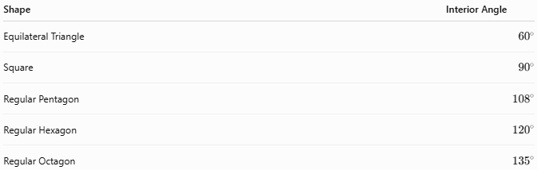
Shape | Interior Angle
Equilateral Triangle | $${60}^{∘}$$
Square | $${90}^{∘}$$
Regular Pentagon | $${108}^{∘}$$
Regular Hexagon | $${120}^{∘}$$
Regular Octagon | $${135}^{∘}$$
All are less than:
$${180}^{∘}$$

Irregular Convex Shapes
# Source: AI Source: Provided by: [Data Path: Persons Table -> ID Column: 1, Name_En Column: Motasem Essam] -> From: [ChatGPT] on [7/25/2026]
A shape can be convex even if it is not regular.
Examples:
- Unequal-sided convex quadrilateral.
- Irregular convex pentagon.

Real-World Examples
# Source: AI Source: Provided by: [Data Path: Persons Table -> ID Column: 1, Name_En Column: Motasem Essam] -> From: [ChatGPT] on [7/25/2026]
Convex shapes appear in:
- Plates.
- Coins.
- Balls.
- Building outlines.
- Traffic signs.
- Windows.
- Tables.
- Shields.
- Product designs.

Applications
# Source: AI Source: Provided by: [Data Path: Persons Table -> ID Column: 1, Name_En Column: Motasem Essam] -> From: [ChatGPT] on [7/25/2026]
Convex shapes are important in:
- Plane Geometry
- Computational Geometry
- Computer Graphics
- Robotics
- Optimization
- Engineering
- Architecture
- CAD (Computer-Aided Design)
- GIS

Advantages
# Source: AI Source: Provided by: [Data Path: Persons Table -> ID Column: 1, Name_En Column: Motasem Essam] -> From: [ChatGPT] on [7/25/2026]
Studying convex shapes helps to:
- Simplify geometric calculations.
- Determine shortest paths.
- Solve optimization problems.
- Analyze visibility and collision detection.
- Create efficient designs.

Limitations
# Source: AI Source: Provided by: [Data Path: Persons Table -> ID Column: 1, Name_En Column: Motasem Essam] -> From: [ChatGPT] on [7/25/2026]
Convex shapes:
- Cannot represent shapes with indentations.
- Are less flexible for complex natural forms.
- May not accurately model irregular objects.

Comparison with Concave Shapes
# Source: AI Source: Provided by: [Data Path: Persons Table -> ID Column: 1, Name_En Column: Motasem Essam] -> From: [ChatGPT] on [7/25/2026]
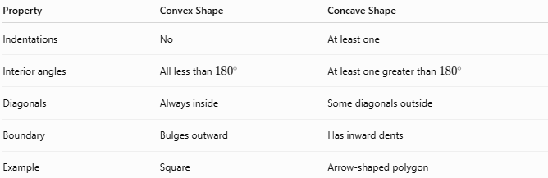
Property | Convex Shape | Concave Shape
Indentations | No | At least one
Interior angles | All less than ${180}^{∘}$ | At least one greater than ${180}^{∘}$
Diagonals | Always inside | Some diagonals outside
Boundary | Bulges outward | Has inward dents
Example | Square | Arrow-shaped polygon

Key Points
# Source: AI Source: Provided by: [Data Path: Persons Table -> ID Column: 1, Name_En Column: Motasem Essam] -> From: [ChatGPT] on [7/25/2026]
- A Convex Shape has no inward dents.
- Every segment joining two internal points stays inside the shape.
- Convex polygons have:
$$\text{All interior angles}<{180}^{∘}$$
- All diagonals remain inside.
- Examples:
  - Triangle.
  - Square.
  - Circle.
  - Rectangle.

Conclusion
# Source: AI Source: Provided by: [Data Path: Persons Table -> ID Column: 1, Name_En Column: Motasem Essam] -> From: [ChatGPT] on [7/25/2026]
A Convex Shape is a geometric figure whose boundary curves outward and contains every line segment connecting any two points inside it. Convex shapes have no indentations, and convex polygons have all interior angles less than ${180}^{∘}$. They are fundamental in plane geometry, computational geometry, optimization, engineering, robotics, CAD, computer graphics, and GIS, where their simple structure makes them valuable for measurement, modeling, and problem solving.

